**About the Data (could be drop down text)**

The data displayed here is sourced from **Scamwatch**, a trusted initiative led by the **National Anti-Scam Centre**. We have taken their latest data, analyzed it, and presented the most recent scam trends specifically targeting senior Australians. This data is updated monthly.

The graph below highlights the top three most reported scams affecting senior Australians in the past month. It shows total number of reports for each scam type.

**X axis – Scam Type**

**Y axis – Number of Reports**

The graph below illustrates the top three scams caused the largest financial losses (in AUD) for senior Australians in the past month. It shows total loss caused by scam type.

**X axis – Scam Type**

**Y axis – Financial Loss**

The graph below shows the top three most frequently used contact methods by scammers targeting senior Australians in the past month. It shows the total number of reports for each contact method.

**X axis – Contact Method**

**Y axis – Number of Reports**

**About the Data (could be drop down text)**

The data displayed here is sourced from **Scamwatch**, a trusted initiative led by the **National Anti-Scam Centre**. We have taken their latest data, analyzed it, and created the tool that would help you to identify you personal risks of being scammed based on your demographics and online activity. This data I updated monthly.

**How to use this report (could be drop down text)**

* Use the dropdown menus to select our online activity methods or demographics
* One you make and submit your selections the appropriate data will be displayed.

(text below to appear with graphs)

The graphs below provide insights into scam risks based on the contact methods you select.

* The left graph highlights the types of scams senior Australians are most likely to be exposed to (compared to national average) when using the selected contact method.
* The right graph displays the average financial losses caused by these scams

**X axis – Scam Type**

**Y axis (right graph) – Exposure Risks**

**Y axis (left graph) – Average Loss**

(text below to appear with graphs)

The graphs below provide insights into scam risks based on the demographic information you have selected.

* The left graph shows the types of scams that individuals in your selected demographic most likely to be exposed to.
* The right graph highlights the average financial losses caused by these scams

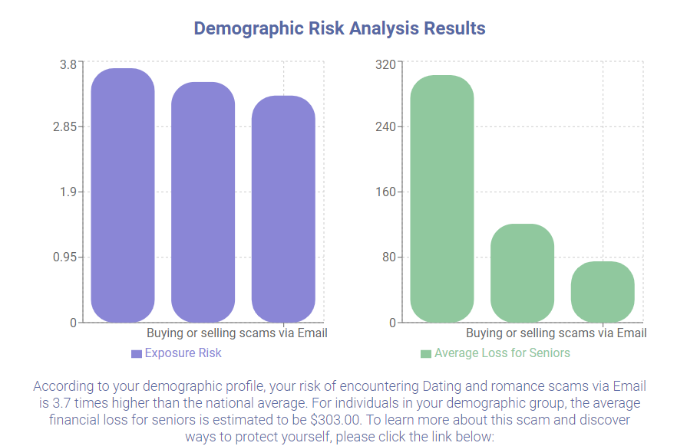

**X axis – Scam Type**

**Y axis (right graph) – Exposure Risks**

**Y axis (left graph) – Average Loss**